**Timesheet Request**

Current Flow

When a user is unable to fill out the timesheet for the past 10 days, the timesheet request option becomes visible (Please note till December it was for 7 days).

Upon clicking the Timesheet Request button, a form appears, prompting the user to provide the following details:

* Client
* Assignment
* Partner
* Reason

The partner has the option to approve, reject, or request clarification.

**Partner Approves:** Upon approval, the user can fill in their timesheet for the last 30 days.

**Partner Rejects:** If the timesheet request is rejected, the user can re-request. How many times can the re-request be sent?

**Partner Request Clarification** The partner seeks clarification, and the request is put on hold until the employee gives clarification. Then, the partner can approve or reject it.

If rejected, then the user may create a new request and will go through the same process.

**Updated Flow – Jan 2024**

When a user clicks on the timesheet request, a form appears, prompting the user to provide the following details:

* Payroll month
* Client
* Assignment
* Partner
* Reason

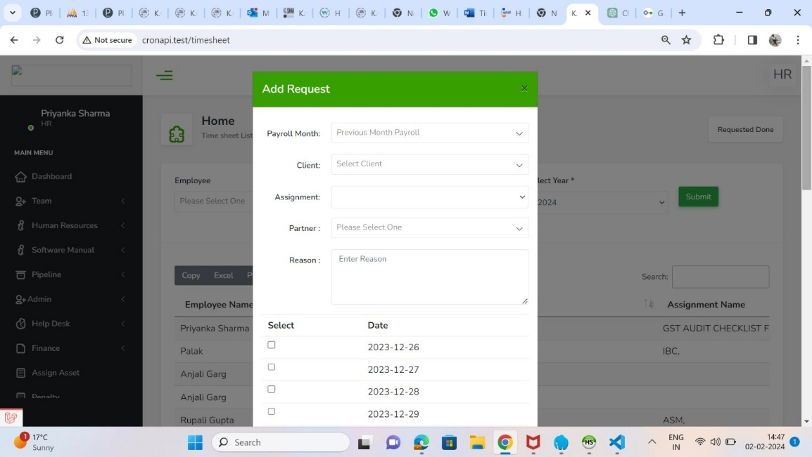

**Timesheet Request for Current Payroll Month**

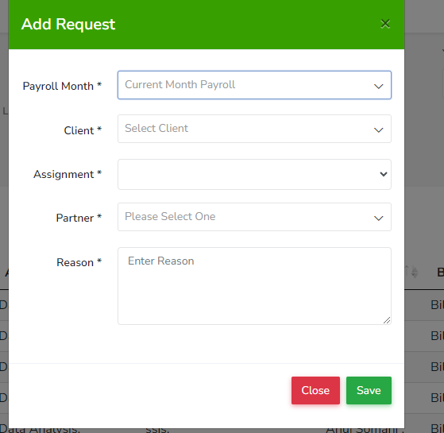

Once the user submits the request.

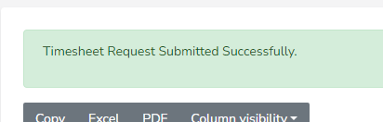

If the user selects the current payroll month and sends a request to the partner, and if the request is approved, the timesheet option will be available for the period from the **26th** of the current payroll month to the current date.

This will display ALL current timesheet slots

**Timesheet Request for Previous Payroll Month**

If the user selects the last payroll month, all data related to user from the last payroll's timesheet will be displayed. The user can then select Specific dates using checkboxes and send a request for those dates to their partner.

The partner has the option to **approve or reject Timesheet Request**

If user requests multiple dates from last payroll, the partner can choose to approve the specific dates (checkbox) among the displayed date or Select all.

1. Partner Approves All – all the slots will go to Final Partner

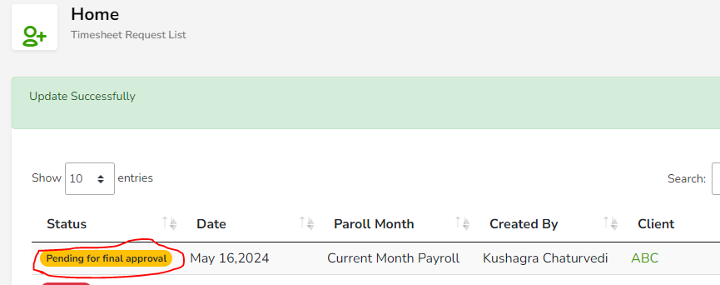

1. Partner Rejects All – None of the slots will go to Final Partner.

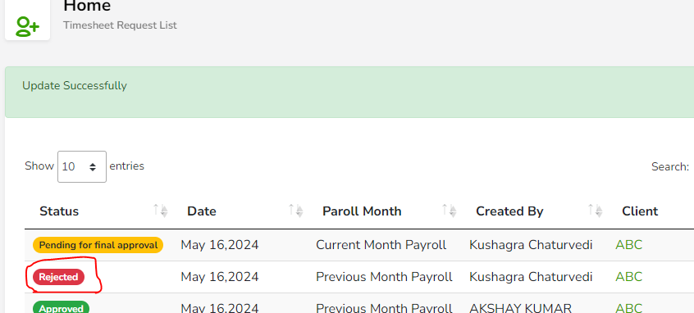

1. Partner Approves Some and leaves the rest unapproved

Note: The Request sent to partner shows:

1. Payroll cycle for which the request is sent
2. Check-in details

**(Interim) Partner action:**

1. **Select All & send** – Status changes to ‘Pending for Final Approval’
2. **Select some & send** – Status changes to ‘Pending for Final Approval’
3. **Reject All & Send** - Status changes to ‘Rejected’

You cannot Reject Some; Not approving some means they are rejected**: application has a validation check**

The request is sent to Final Partner (Anuj) only for **the approved slots**

**Final Partner can**

1. Select All
2. Reject All
3. No provision for partial section/rejection

* Hold option available for Final Anuj; To ask for **Clarification**
* When Final Partner holds the request; status changes to **‘Hold”**

GAPS in this flow:

1. Application allows user to select 1 client 1 Assignment 1 Partner for the payroll cycle – current or previous

User could have worked with multiple clients/assignments/Partner

Solution:

* Since we have check-in details the slots should be displayed with relevant context to the employee.

|  |  |  |  |  |
| --- | --- | --- | --- | --- |
| SELECT | DATE | PARTNER | ASSIGNMENT | PARTNER |

* When the employee selects the slot and sends
* Mails should go to relevant partners
* If employee selected more that 1 slot for the same partner then both the slots should be sent in one mail request

TAT for Partner:

Once the request is sent the timesheet request is closed from employee’e end.

* Partner Approves all the slots and the attendance data gets updated
* Partner Rejects all the slots and the attendance data gets updated
* Partner seeks Clarification and the loop closes after the clarification is resolved – slot(s) is approved or rejected and attendance data gets updated
* Partner approves some and rejects some and the attendance data gets updated

**Current payroll** the update is done and the employee gets paid

**Previous payroll** – arrears are generated which need to be included in the next payroll cycle

* Partner does not reply. In such cases the Time sheet request needs to be available to the employee – Resend Request

How frequently can employee resend timesheet request

How to ensure that Partner responds

* Partner responds but Final partner does not respond?
* The application will not open the request again as Partner has responded

**Issue**

In the current module, there is a bug where the user can create multiple timesheet requests, and partners may get confused about which ones to approve.

Suggestion;

To address this issue, after a timesheet request is created, we can configure a system to check for 4 days. During this time, the user cannot create a new request but can send reminders.

After 4 days, if the request is not approved or rejected, then the request is invalid, and the user can create a new timesheet request. This cycle continues.

**Need Clarification**

1. How do we manage the last payroll timesheet data in the current payroll?

Suggestions: Can we display the last payroll data in the current payroll sheet in a single column with a count? HR can click on the count to view the data in a pop-up. Through this data, HR can manually add amounts in the form of arrears, or we can incorporate dynamic options for adjustments.

2. Can we map check-in data for the date the user requests to open for filling timesheet? Partners may not remember data from one month ago, and by providing a check-in report for a specific date, partners can easily approve or reject the timesheet request.